1st project : Eureka – Server

Starter -🡪 Web Starter

Starter 🡪Eureka Starter

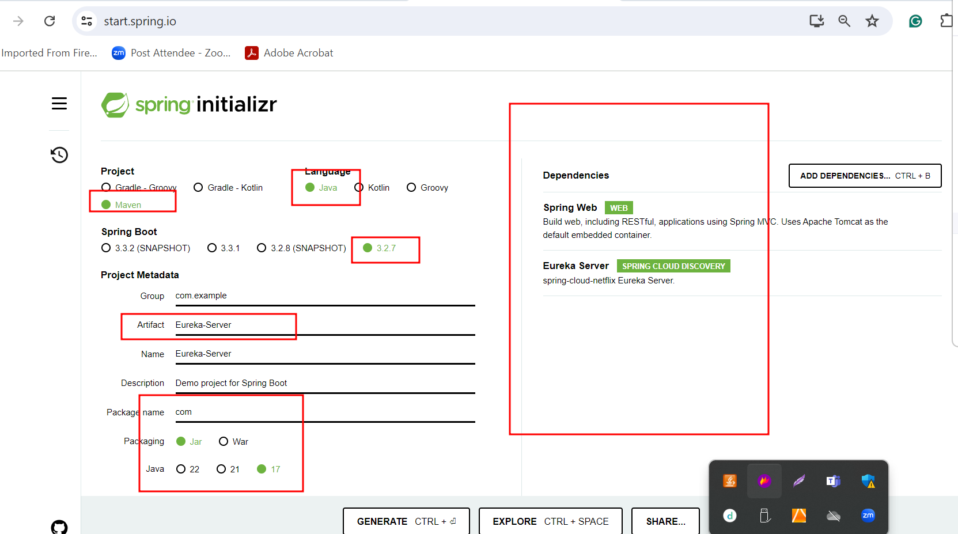

application.properties file

server.port=8761

eureka.client.register-with-eureka=false

eureka.client.fetch-registry=false

in main class @EnableEurekaServer annotation and run the project.

Then check <http://localhost:8761>

restTemplate.getForObject(“url/+”+to+”/”+from,

restTemplate.postForObject(“url”,booking,String.class);

2nd project : book the cab (micro service project @Controller then

View can be jsp, html or thymeleaf etc.

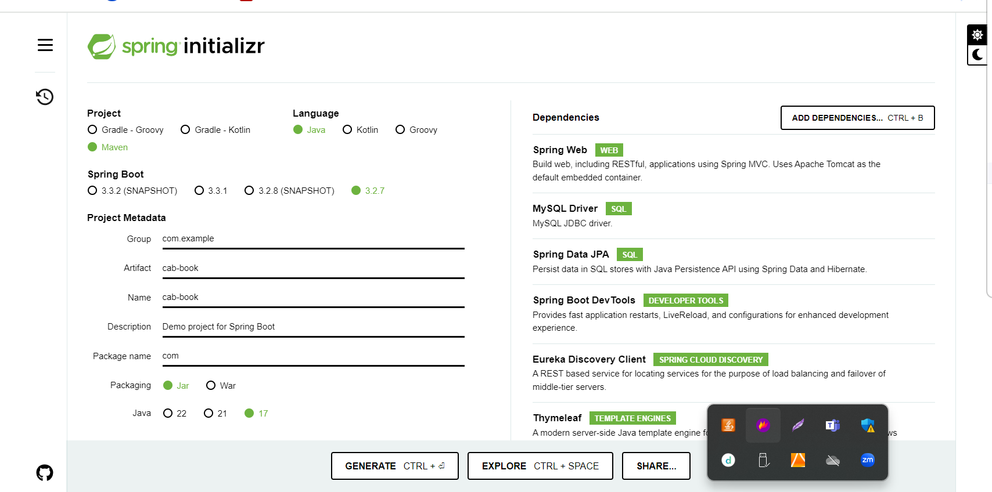

Application.properties file provide database details.

Server.port=8181

Entity class bookid(pk) auto increment, name, from, to, typeofcab, amount etc

Repository (BookCab extends JpaRepository )

Service : auto wired for Repository as well as RestTemplate

Bookcab (){

Base upon condition book the cab else return error message.

}

findFare(){

Using resttemplate find amount passing value as from, to, typeofcab

}

Controller : normal controller with view as thymeleaf

First method to open index page.

Second method to open form which help to pass name,to,from,typeofcab etc.

Third method to call service method to book the cab.

Forth method to find cab fare base upon from, to, typeofcab

Inside template folder index.html

Hyper link

Book the cab

Calculate the fare

Inside this project please add bootstrap link to apply styling or CSS.

Bookid(PK) auto_increment, person name, from, to, typeofcab, amount etc

3rd project : calculate cab fare (micro service project) Rest API :@RestController

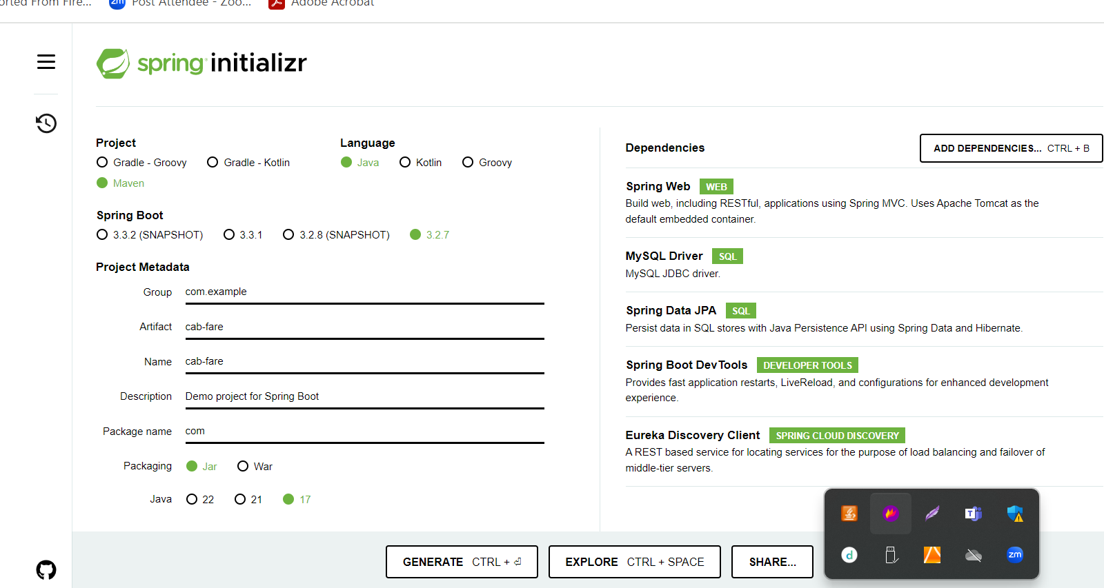

CabFare fareid(PK), from, to, typeofcab, amount etc (Entity class)

Repository (CabFareRepository extends JpaRepository)

Service

One method to store cabfare information (optional)

Method retrieve amount base upon input as from, to , typeofcab etc.

Controller (rest controller )

Post mapping method to store cabfare information (optional)

Getmapping method to retrieve amount using pathparam taking information as from, to, typeofcab etc

Application.properties file please provide database details.

server.port = 8282

Fareid, from, to, typeofcab, amount

1 A B innova 750

2 A B santro 500

3 A C innova 1200

Web Service

JSP or Servlet

If we want to make Servlet or JPS as web service ie Rest full web service

JAX_Rs : Using jersey implementation